* Turn off lights and close door after last student has left room.
* Evacuate building in an orderly fashion to the nearest exit.
* Position students as far from the building as possible
* Take grade book; account for all students.
* If it is a drill, listen for signal to return to class.
* If it is a real emergency, wait for further instructions from administration.
* If you are the first to notice a fire, pull alarm and call *911.*

**Tornado**

* If a Tornado Watch is announced, it indicates conditions are right for a tornado. **Be Alert!**
* If a Tornado Warning siren sounds, teachers should take students to a designated area in the hall way.
* Students are to couch facing the wall with their heads covered until further directions are given or an “all clear” announcement is made.

**Medical Emergency**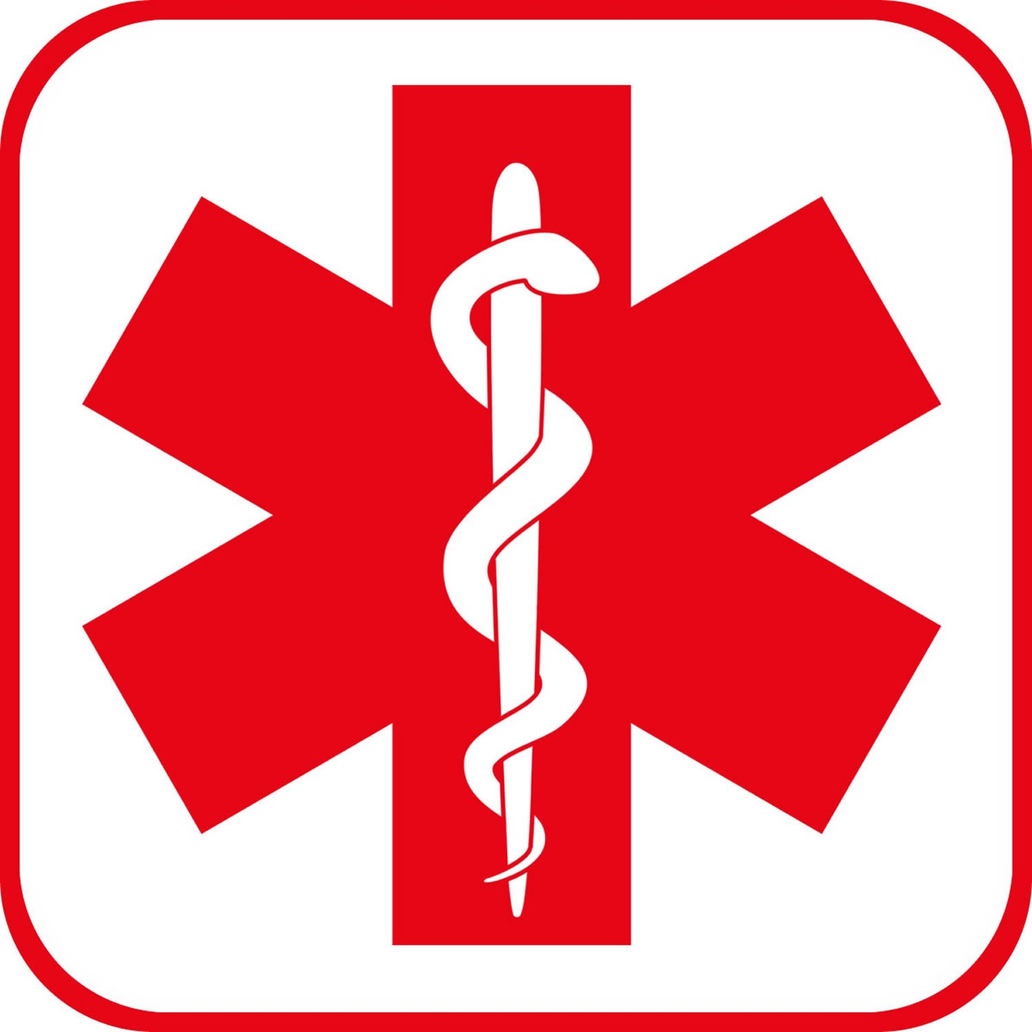

* Call *911* immediately.
* Alert office of emergency.
* Keep bystanders away from incident.
* Comfort injured person until help arrives.

**Bomb Threat **

* Account for all students; take grade book with you.
* Evacuate building-get as far away from building as possible.
* Keep bystanders away from incident.
* Comfort injured person until help arrives.
* Leave lights ON.
* Leave doors OPEN.
* Do not use cell phones or walkie-talkies.
* Account for all students after evacuation.
* Listen for further instructions from administration .

A newsletter also can extend classroom learning. Give students experience in writing for an audience by having them write articles describing class projects. Ask children to help you choose the colors of your newsletter, pick out clip art, put together story ideas, write and edit articles, and distribute the newsletter.

* Account for all students.
* Lock doors.
* Shut windows and close blinds.
* Position students away from windows and doors.
* Keep classroom quiet.
* Wait for further instructions by administration.

**Dealing With Student  Disturbances**

* Identify office immediately after a physical altercation has occurred.
* Acquire adequate assistance before attempting to break up an active physical altercation.
* Utilize verbal commands with students involved in alteration to ensure they are aware that staff members are attempting to stop the altercation.
* Students should immediately be separated as soon as altercation has been dissolved.
* Evaluate any injuries.
* Document accounts of each student regarding what happened.
* A report to law enforcement is required if there are visible signs of injury or in the event that it is obvious a violation of state law is present.
* Staff member trained in non-violent crisis intervention (CPI) are encouraged to be utilized in these situation .
* **School administration should be notified of ALL incidents involving physical altercations.**

**Explosion or Earthquake**

* All students and teachers should assume a duck and covered position under tables/desks while holding onto the tables/desks
* Stay in position until evacuation symbol given
* When signal given, evacuate to the nearest exit

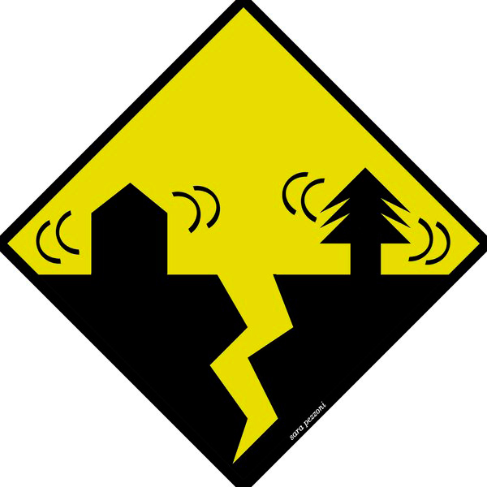

# Intruder/Lockdown C:\Users\beth.csiszer\Desktop\lockdown.png

#### Fire C:\Users\beth.csiszer\Desktop\Fire-symbol.png

South Middle School Quick Emergency Quick Reference Guide