ESOL Apps
There are literally thousands of educational apps on the market. Here are just of a few of the many available and what they do. Check the iTunes and Google Play store often to see what is available. (Most Apps are available now on both Apple and Android unless specified)

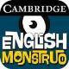English Monstruo (available for Apple and Android): A free app that contains eight games designed to help students learn verb conjugation. It was created by at Cambridge University by researchers who examined the results of 200,000 exams to determine the words that give Spanish speakers the most difficulty. The games in the English Monstruo app contain activities such as fill-in-the-blank, sorting words and replacing incorrect words with correct words.
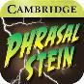 Phrasalstein, (available for Apple and Android): Was designed by Cambridge University to help students learn the meanings of phrasal verbs. It has a practice mode and a quiz mode. Translations of the meanings are available in Spanish, German, Italian, Russian and French.
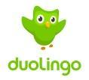Duolingo (available for Apple, Android and online): A free service designed to help you learn Spanish, French, German, or Portuguese The activities include ones that help learn you learn to read, listen to, and translate words and phrases.
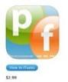Phonetics Focus (available for Apple): An interactive app that helps users work on their English pronunciation. There are quizzes, flashcards, and native-speaker audio to help students of English learn phonetics quickly and accurately
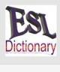American Wordspeller ESL: Helps people with different dialects and languages find words in English based on their phonetic pronunciation. Users can type in how the word sounds to them, and the app helps them find the correct spelling and definition.
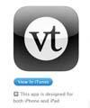VoiceThread: This app captures and connects conversations around documents, snapshots, diagrams and videos. Users can talk, type, and draw right on the screen, and join in the conversation from across any iPhone or iPad device.
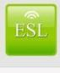ESL Podcast: App that offers podcasts about English language and culture
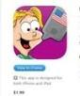Learn To Talk More Words: This app includes 115 audio flash cards to help early language development and uses both sight and sounds to teach toddlers and early language learners’ basic vocabulary.
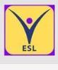ESL Edition-eCOVE Software: This tool helps track learning and student behavior. Teachers can use the apps matrices to help check student understanding and continue best practices in ESL teaching.
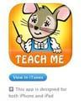TeachMe: Kindergarten & Teach Me: 1st Grade: This app helps children learn reading and writing, rewarding their success along the way. It can read a child’s answers for spelling and math questions, and show them how to write the correct answer should they need help.
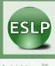 ESL Player: A shortcut to the “English as a Second Language Podcast” player. Students can find current and archived episodes of this educational podcast to support them in learning English.
Learn English, ESL, TOEFL: This ESL app offers flashcards and a phrasebook that includes pictures, text, and correct audio pronunciation. Lessons can be tailored to all needs and levels of learning, including adults, children, beginners, and advanced.
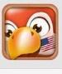 Learn English: Contains over 800 commonly-used English phrases and vocabulary. The parrot teaches you by helping you to practice your speaking and listening skills
Supiki English Conversation Speaking Practice: Has been proven multiple times to help users increase their fluency and refine their skillset related to the English language. The app differentiates itself from others by being able to actually talk back to the user.
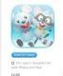 Speech With Milo Apps: Was created by a licensed speech-language pathologist and is great for children to understand how to properly say words.
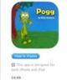Pogg — Spelling & Verbs: Designed for children that frames common errors children make related to spelling and speech.
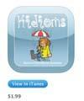Kidioms: Helps children understand idioms, especially those learning English as a second language. It breaks down the vocabulary into useful categories that many will find helpful, including by grade level.
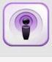ESL English Study: A useful podcast collection which allows the listener to study English through listening, speaking and playing games.
ESL Pod: Podcast organized in several thematic channels (news, economy, everyday life, etc.). There is also a section to help prepare the TOEFL (test of English as a foreign language) which is required to access many universities.
Speak ESL English Free: Designed for English speakers of other languages .It the words you need to survive in an English environment like an English speaker in high school.
Grammar Up: Focuses on Grammar skills and how to avoid common pitfalls.
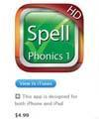Simplex Spelling – An app designed to teach the rules of spelling in the English language.
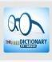 The Free Dictionary: This dictionary app is a comprehensive dictionary of English, Spanish, French, and 11 other languages. It also offers a translation option.
Learn English 6000 Words: An app in which the player can learn over 6000 vocabulary words with illustrations, phonetic transcriptions and pronunciation recordings.
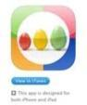Comparative Adjectives: Students use comparative words with colorful illustrations
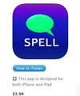Spell & Listen cards: Talking flashcards for spelling designed for kids 3 – 10 organized in increasing order of difficulty to teach spelling and vocabulary.
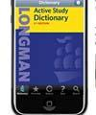Longman Dictionary: is an innovative tool for keeping one of the best dictionaries at your fingertips with this app. There are a range of different add-ons contained within the app, including phrasal verbs, English-Japanese Dictionary, key words, and more.
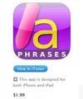15500 Useful English Phrases: Helps those learning English take their knowledge to the next level by offering the most important phrases to help them communicate effectively.
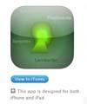 iLearning: Vocabulary Trainer: a vocabulary trainer for school, education and personal purposes. All learning units are displayed on the app, showing the last rate of the correct answers, the lowest and highest learning level reached so far using colors, and the remaining time in days until vocabularies should be recalled.
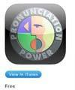Pronunciation Power: The ultimate in new English language learning technology for beginner to intermediate learners. This app translates into 12 different languages and uniquely features hours of exercises for practicing Stress, Timing, Articulation, Intonation and Rhythm (S.T.A.I.R.).
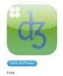Sounds Right: An app published by the British Council and has in-depth content for breaking down pronunciation of various words in the English language.
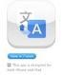Google Translate Is the world-renowned app for translating a multitude of languages easily and effectively. Additionally, it is capable of having spoken translations read aloud.
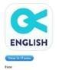Voxy: Offers English lessons based on the users based on your level, interests and goals. It also connects users with native English-speaking tutors whenever needed.
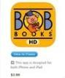Bob Books: An app that teaches children how to make the connection between letters and sounds.
.
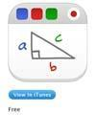Educreations Interactive Whiteboard: Takes an iPad and makes it an interactive whiteboard that is also recordable. Updates in the app have allowed new features to be developed that include the creation of an animated lesson, adding commentary to photos, and much more.
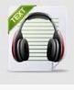 Fluent English Plus: Increases fluency for anyone with basic English skills. Users can listen to audio books, read along to the text and tap any word to see a translation.

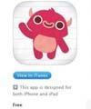Endless Reader: Introduces “sight words” to children, like the most commonly used words in school, library, and children’s books. Kids learn with interactive word puzzles, illustrations and fun animation.
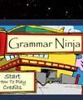 Grammar Ninja Grammar Ninja: Is a web app helps users study grammar and parts of speech. Students learn how to identify verbs, nouns, adjectives and more.
C is for Cow: Teaches students to recognize both the phonetics and look of each letter in the English alphabet. A child can tap a letter to hear its sound, and see a corresponding animal that starts with that letter, building a child’s vocabulary.
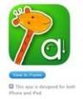 iWriteWords Lite, The free version of iWriteWords, was created to teach children how to write and say words.
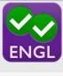Magoosh English Video Lessons: Has 85 animated lessons, along with grammar basics, nouns, verbs, and the particularly tricky clauses. The app was created by an expert tutor who has over a decade of teaching English to students.
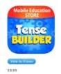Tense Builder: Helps students understand the various contexts in which it is appropriate to use each tense of a word. The app has 48 target verbs and displays impressive depth on its ability to further foster tense skills.

